

规 格 承 认 书
SPEC FOR APPROVAL

客户名称
Customer
客户料号
Customer P/N
我司型号  Model | SK-IR5FT-F14120-A
产品名称  Product Name | 直插红外发射管

客户确认(Customer Signatures)
编制(Edit) | 审核(Check) | 核准(Approval)

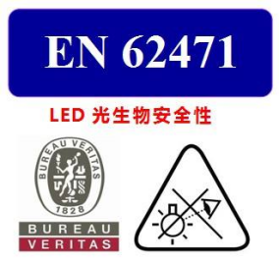



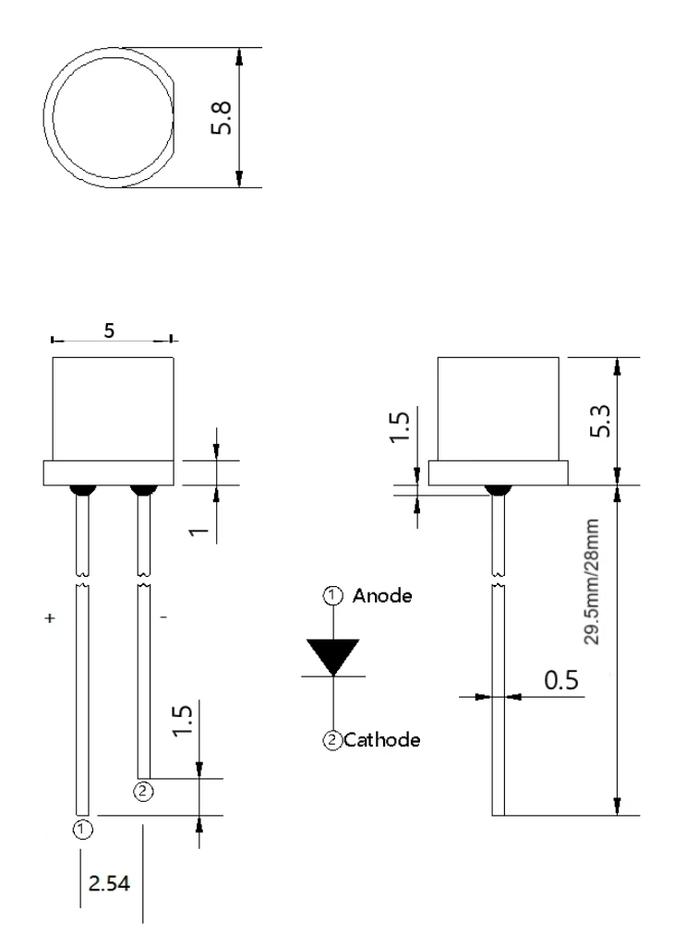
产品外形尺寸Package outline dimensions

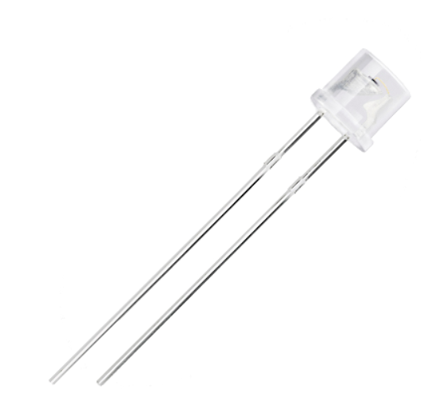

注/Notes: 1. 单位 : 毫米（mm）/All dimensions are in millimeters.
2. 公差 ：如无特别标注则为± 0.15 mm/Tolerance is ± 0.15 mm unless otherwise noted.
应用Applications
  - 人脸识别 Face recognition
  - 监控系统Surveillance System
  - 红外相机 Infrared Illumination for cameras
  - 机器视觉系统 Machine visual systems
  - 智能家居 Smart home
  - 虹膜识别Iris Recognition
  - 红外遥控对管Infrared remote control tube

特性Features
  - 峰值波长850nm Peak wavelength 入p=850nm
  - 高可靠性High reliability
  - 低功耗 Low Power Consumption
  - 散热快Fast heat dissipation
  - 发光角度均匀Uniform luminous angle
  - 符合RoHS compliant RoHS
  - 可回流焊接 Soldering methods:Reflow soldering

额定参数Absolute Maximum Ratings (Ta=25℃)
电气特性  Electrical characteristics | 符号  Symbol | 额定值  Rated Value | 单位  Unit
最大持续工作电流  Max continuous working current | IF | 100 | mA
最大脉冲工作电流*  Max pulse current | IFP | 1000 | mA
反向击穿电压  Reverse breakdown voltage | VR | 5 | V
最大功耗  Power dissipation | Pd | 90 | mW
工作温度  Operating Temperature | Topr | -30--+85 | °C
储存温度  Storage Temperature | Tstg | -40--+100 | °C
Note：* Pulse width≦100μs, Duty≦1%

光电特性Elector-Optical Characteristics (Ta=25℃)
参数  Parameter | 符号  Symbol | 测试条件  Test Condition | 最小  Min | 典型  Type | 最大  Max | 单位  Unit
峰值波长  Peak wavelength | 入p | IF=80mA | -- | 850 | -- | nm
辐射光强  Radiation intensity | Po | IF=80mA | 15 | 20 | -- | mw/sr
工作电压  Forward Voltage | VF | IF=80mA | 1.3 | 1.4 | 1.8 | V
反向电流  Reverse current | IR | VR=5V | -- | -- | 10 | μΑ
发射角度  Emission Angle | 2θ½ | IF=80mA | -- | 120 | -- | Deg.

光电特性曲线Typical elector-optical characteristics curves
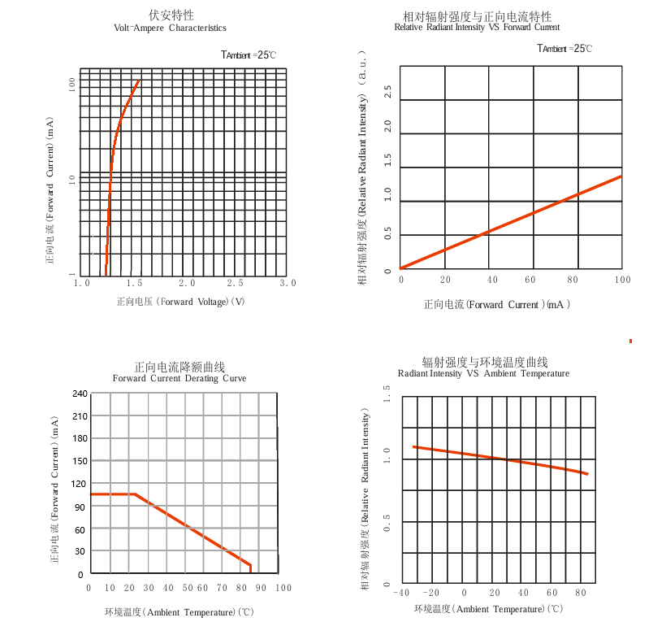

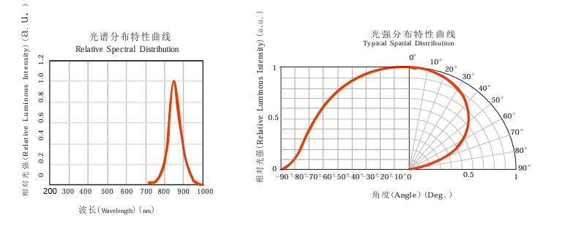

推荐焊接条件Recommended Soldering Conditions
焊接模式Mode |  | 固定形式Fixed form
手工焊接  Manually Soldering | 烙铁温度  Soldering Iron Temperature | 最高温度300℃(功率最大30瓦)  300℃ Max(30w Max)
手工焊接  Manually Soldering | 焊接时间  Soldering Time | 时间不超过3秒  3 sec Max
手工焊接  Manually Soldering | 焊接位置  Soldering Position | 大于3mm (从焊点到胶体)  3mm Min.(Form soldering joint to colloid)
波峰焊接  Wave Soldering | 预热  Preheat | 最高温度100℃ 不超过60秒  100℃ Max.60 sec.Max
波峰焊接  Wave Soldering | 温度  Temperature | 最高260℃  260℃ Max.
波峰焊接  Wave Soldering | 焊接时间  Soldering Time | 不超过5秒  5 sec Max
锡炉焊接  Solder pot Soldering | 预热  Preheat | 最高温度100℃ 不超过60秒  100℃ Max.60 sec.Max
锡炉焊接  Solder pot Soldering | 浸焊温度  Preheat Temperature | 最高260℃  260℃ Max.
锡炉焊接  Solder pot Soldering | 浸焊时间  Soldering Time | 不超过5秒  5 sec Max
锡炉焊接  Solder pot Soldering | 焊接位置  Soldering Position | 大于2mm (从焊点到胶体)  2mm Min.(From soldering joint to colloid)
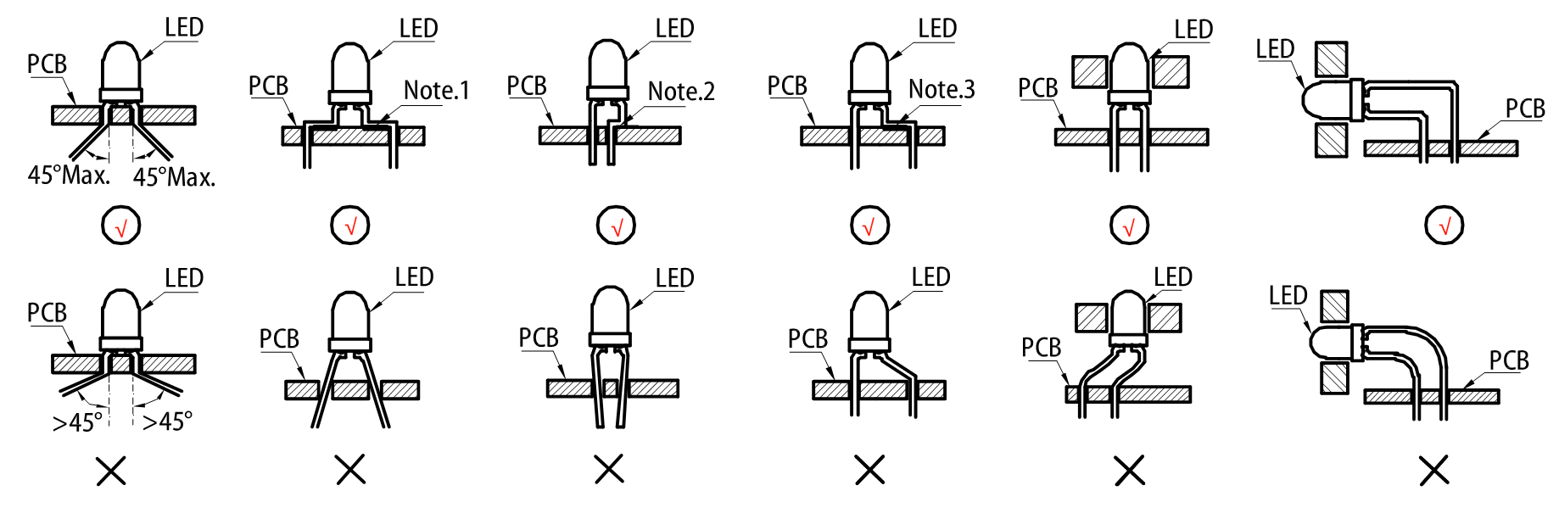
加工注意事项：
  - 储存Storage
- 在温度不高于30℃，湿度不高于60%RH的条件下，产品保存期限为6个月。将产品保存在密封的容器中并附带干燥剂可以在一定程度上延续产品的储存日期。不良的储存条件会导致产品引脚的腐蚀或产品性能的改变。
Under the storage conditions of 30℃ or less and humidity less than 60%RH, the storage period of LED is 6months. Store the products in sealed container with moisture absorbent material could prolong the storage time to a certain extent. Bad storage conditions may cause the LED pin corrode or LED characteristics be changed. It is recommended that the LEDs be used as soon as possible.
- 开封后,产品必须24小时内使用完(建议工作环境温度不高于30℃,湿度不高于60%),如未使用完,余料须存放在温度不高于30℃,湿度不高于10%的环境中。
After opening package, the product should be soldered within 24 hours. If not, please store at 30℃ or less and humidity less than 10%RH. It is recommended that the product be operated at the workshop condition of 30℃ or less and humidity less than 60%RH.
- 对于尚未焊接的LED,如果吸湿剂或包装失效,或者产品没有符合以上有效存储条件,烘烤可以起到一定的性能恢复效果. 烘烤条件:65±5℃,持续时间24H。
For the LED doesn’t solder ,if the moisture absorbent material lose efficacy or the storage condition doesn’t conform to the above description,baking can help performance recovery in some extent.Backing condition : 65±5℃ for 24 hours.
  - 静电Static electricity
- 静电和电涌会导致产品特性发生改变，例如正向电压降低等，如果情况严重甚至会损毁产品，所以在使用时必须采取有效的防静电措施。所有相关的设备和机器都应该正确的接地，同时必须采取其他防静电和电涌的措施。使用防静电手环，防静电垫子，防静电工作服，工作鞋，手套，防静电容器，都是有效的防止静电和电涌的措施。
Static and electric surge would change the features of LED,such as decreasing of forward voltage.Even damages may occur in serious conditions.Please make sure adopt effective anti-static measures. All the relative devices and machinery must be properly grounded. At the same time, it is recommended to use anti-static wrist bands,anti-electrostatic gloves, anti-electrostatic containers and so on to prevent static and electric surge.

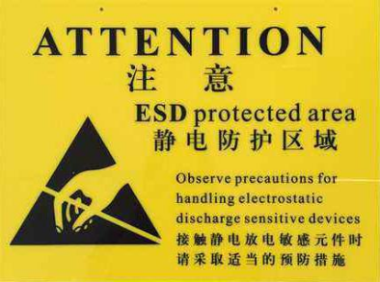

可靠性焊接温度（A 图、B 图）Soldering temperature curve chart（figure A、figure B）

A图波峰焊 B图回流焊
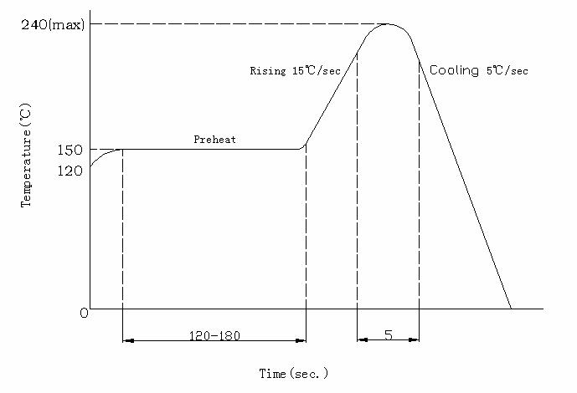
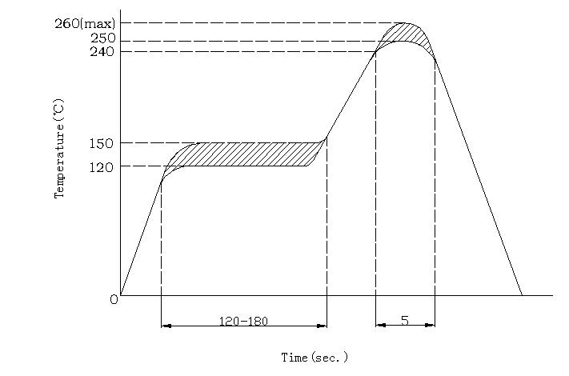

可靠性试验Reliability Test
测试项目  Test Parameter | 测试条件  Test Condition | 时间  Time | 样品数Quantity | Ac/Re
耐焊接热  Resistance to Solder Heat | 260℃±5℃ | 10 sec | 22PCS | 0/1
冷热循环  temperature cycle | +100℃(15min) 5min  -10℃(15min) | 50 cycles | 22PCS | 0/1
冷热冲击  Thermal Shock | +105℃(30min) 5min  -45℃(30min) | 50 cycles | 22PCS | 0/1
高温贮存  High Temperature storage | +100℃ | 1000H | 22PCS | 0/1
低温贮存  Low Temperature storage | -40℃ | 1000H | 22PCS | 0/1
寿命测试  Life Test | VCE=5V | 1000H | 22PCS | 0/1
高温高湿  High Temperature and High Humidity Test | 85℃&85%R.H | 168H | 22PCS | 0/1

包装规格Packing Specification
最小包装：1000PCS/包Minimum package: 1, 000 PCS/ package

